**IBM Cloud Service**

|  |  |
| --- | --- |
| Date | 19 November 2022 |
| Team ID | PNT2022TMID47580 |
| Project Name | Smart Solutions for Railways |

**IBM Watson IoT Platform :**

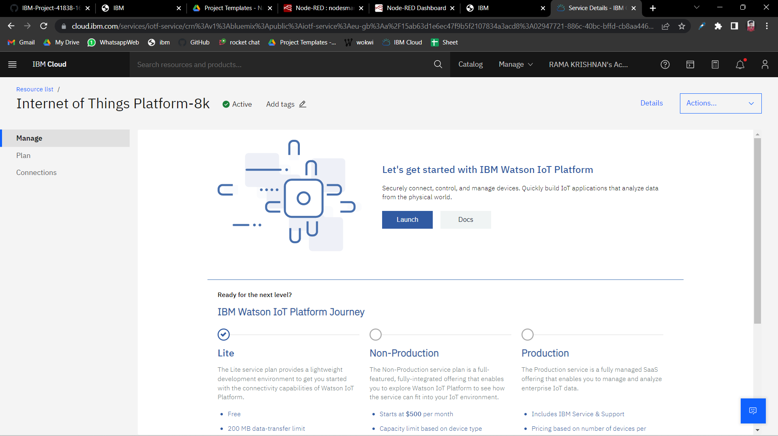

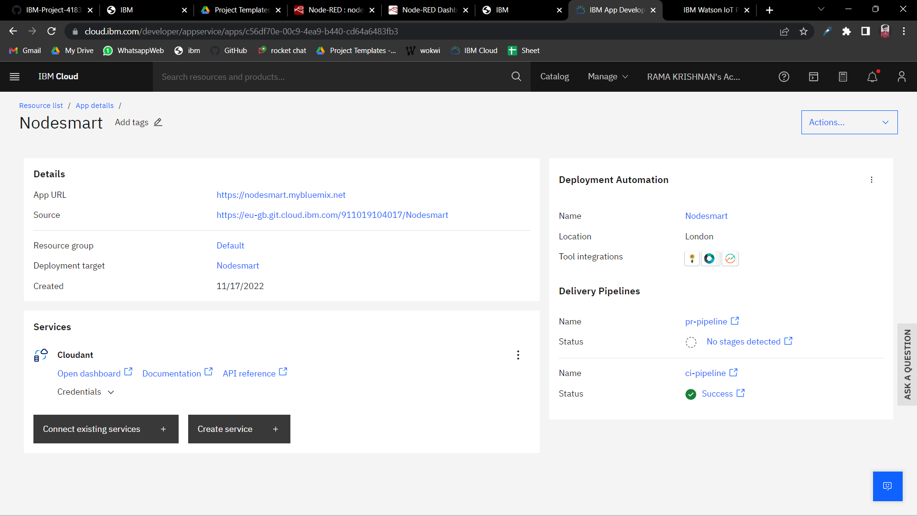**Node-Red Service:**

**Cloudant DB:**

